The University of Nottingham

DEPARTMENT OF MECHANICAL, MATERIALS AND MANUFACTURING ENGINEERING

A LEVEL 3 MODULE, SPRING 2019-2020

THERMOFLUIDS 3

Time allowed TWO Hours

Candidates may complete the front cover of their answer book and sign their desk card but must NOT write anything else until the start of the examination period is announced

Answer ALL questions from Section A and ONE question from Section B

Only silent, self contained calculators with a Single-Line Display or Dual-Line Display are permitted in this examination.

Dictionaries are not allowed with one exception. Those whose first language is not English may use a standard translation dictionary to translate between that language and English provided that neither language is the subject of this examination. Subject specific translation dictionaries are not permitted.

No electronic devices capable of storing and retrieving text, including electronic dictionaries, may be used.

DO NOT turn examination paper over until instructed to do so

In this examination candidates are required to answer ALL questions in Section A and ONE of the TWO questions in Section B. If a candidate answers more than the required number of questions, both questions will be marked and the highest mark will be used in the final examination mark.

ADDITIONAL MATERIAL: Thermodynamic Properties of Fluids & other data (in S.I Units)
Formula sheet

INFORMATION FOR INVIGILATORS:

Question papers should be collected in at the end of the exam – do not allow candidates to take copies from the exam room.

Section A
Answer ALL questions in this section

- A battery is embedded in a block of resin ($k=0.32 W/mK$) as shown in Figure Q1. Using the values given, what will be the maximum heat flow that you can have from the battery to the surface of the resin if the battery cannot go above $T_{1}=$45 °C and assuming that the surface of the resin is at the ambient temperature of $T_{2}=$20 °C
[4]
You can use the shape factor $S$equation: $S=\frac{2πL}{\ln\left(1.08\frac{w}{D}\right)}$
L=70 mm
w=40 mm
w=40 mm
D=10 mm, $T_{1}={45 }^{o}C$
$$T_{2}={20 }^{o}C$$
Figure Q1: Battery embedded in resin.
Quite simply the heat flow is given by:
$$\dot{q}=kS\left(T_{2}-T_{1}\right)$$
The shape factor S is (2 marks):
$$S=\frac{2πL}{\ln\left(\frac{1.08w}{D}\right)}=\frac{2π0.07}{\ln\left(1.08\left(\frac{0.04}{0.01}\right)\right)}=0.30 m$$
So the heat flow from the battery to the surface is (2 marks):
$$\dot{q}=0.32\left(0.30\right)*\left(45-20\right)=2.4W$$

- When there is little change in the viscosity of fluids with temperature, the overall forced convection across a sphere can be shown to have the following relationship between the Nusselt number, Reynolds number and Prandtl number :
$$\overline{Nu_{L}}=2+\left(0.4 Re_{D}^{\frac{1}{2}}+0.06 Re_{D}^{\frac{2}{3}}\right)Pr^{0.4}, 3.5<Re_{D}<7.6×{10}^{4}, 0.71<Pr<380$$
Using your knowledge of the analogy between heat transfer and mass transfer, rewrite this equation in terms of the overall Sherwood number, the Schmidt number and the Reynolds number to represent the mass transfer from the cylinder. This can be used to simulate a droplet that is evaporating.
[4]
The new equation is:
$$\overline{Sh}=2+\left(0.4 Re_{D}^{\frac{1}{2}}+0.06 Re_{D}^{\frac{2}{3}}\right)Sc^{0.4}, 3.5<Re_{D}<7.6×{10}^{4}, 0.71<Sc<380$$
1 mark for each change and conditions.

- Explain, with the aid of a well-drawn diagram, why there is a contact resistance between two solids in contact. The explanation should include how the smoothness of the surface can affect this contact resistance and how the use of thermal gels can improve the heat transfer performance. Limit your answer to 400 words and a clear, well annotated diagram. [8]
Air gaps
2 marks for diagram. Well drawn with annotations
Tried only gets one mark.
Main points to look for:
- Roughness of surface means that there are air gaps which transfer heat badly (2 mark)
- Smoother surfaces have smaller air gaps and so smaller contact resistance.(2 marks)
- Thermal gels have better conductivity than air and when they fill the gaps they encourage more heat flow. (2 marks)

- Water flowing at 0.5 m/s through a smooth pipe is turbulent. The diameter of the pipe is $D$=30 mm and the surface of the pipe is at 100 °C. Using the Dittus-Boelter equation, estimate the heat transfer coefficient if the water is at an average temperature of 10 °C

Dittus-Boelter equation is:
$\overline{Nu_{D}}=0.023Re_{D}^{0.8}Pr^{n}$, n=0.4 for heating and n=0.3 for cooling of fluid.

First estimate the film temperature as (1 mark) $T_{film}=\frac{100+10}{2}={55}^{o}C$
Using the thermodynamic tables we get (4 marks) :
$μ_{w}=501E-6 kg/ms$, $ρ_{w}=\frac{1}{0.1015E-2}=985.2 kg/m^{3}$, Pr=$3.23$, $k_{w}=0.648 W/mK$

Using these we can calculate the Reynolds number (2 mark) .$Re_{D}=\frac{985.2\left(0.5\right)\left(0.03\right)}{501E-6}=29497$
Heating the water so use n=0.4, so Nusselt number is(2 mark)
$${\overline{Nu}}_{D}=0.023({29497)}^{0.8}{\left(3.23\right)}^{0.4}=138$$

The heat transfer coefficient is(1 mark): $h={\overline{Nu}}_{D}\frac{k_{w}}{D}=\frac{138\left(0.648\right)}{0.03}=2981W/m^{2}K$
If they used n=0.3: answer would be: 2657 W/m²K and still get last mark only.

- Explain with the aid of a well-drawn diagram, the concept of irradiation, Radiosity emission and diffuse reflections. Limit your answer to 400 words and a clear, well annotated diagram.
[8]
(Diffuse)
Reflected radiation =$ρG$
Irradiation $G$
Surface at temperature $T$
Emitted radiation $ϵσT^{4}$
- 2 marks for diagram with all elements
- Irradiation is the radiation impacting on the surface.( 2 mark)
- Some of this is reflected diffusely meaning it is scattered evenly in all directions. (2 mark)
- Energy is also emitted from the surface. Radiosity is the sum of the radiation reflected and the radiation emitted. ( 2 marks for this statement. 1 mark if they only put the equation)

- Write the equation for the equilibrium constant for the following reaction in terms of partial pressures: H2O + CO ⇋ H2 + CO2

$K^{ϑ}= \frac{\left(p_{H_{2}}\right)\left(p_{{CO}_{2}}\right)}{\left(p_{H_{2}O}\right)\left(p_{CO}\right)}$. [4 marks for the correct answer – only two marks if the ratio is the wrong way up

- Discuss three ways in which the efficiency may be increased for a simple Rankine cycle steam plant operating with a final steam temperature of 450 °C and pressure of 80 bar. In each case give at least one advantage and one disadvantage. (Do not write more than about 200 words in answer to this question)
[8 marks]
The efficiency of a simple superheat Rankine cycle can be improved by increasing the mean heat input temperature into the cycle by:
- Increasing the steam pressure (above supercritical for the highest efficiency). This has the advantage of giving a large increase in the mean heat input temperature and reducing the specific steam consumption. But pipework is more expensive to accommodate the higher temperatures and pressures. [2 marks]
- Use of regenerative feed heating. This involves bleeding some steam from the turbine at an intermediate pressure and using in an open or closed feedheater to preheat the feedwater. Several stages of feedheating may be used. Steam flow in HP turbine increases but decreases in LP turbine. Specific steam consumption reduces. There may be a reduction in flue gas outlet temperature from the boiler that could reduce combustion efficiency. [3 marks]

- Use of one or more stages of reheat between the steam turbines. This significantly increases the mean heat input temperature without increasing the maximum steam temperature. Reheat increases the steam dryness at LP turbine outlet. But multi-stage steam turbines are required and there is extra pipework and reheater heat exchangers. In supercritical cycles the increase in efficiency may be limited. [3 marks]

- In a gas turbine the compressor takes in air at a pressure of 1.05 bar and temperature of 15°C. The compressor outlet pressure is 10.5 bar. The turbine entry temperature is 1200°C and the inlet pressure is 10.0 bar. The turbine exhaust pressure is 1.10 bar. The polytropic efficiency of both the compressor and turbine is 90%. Calculate the compressor outlet temperature and the turbine outlet temperature. Assume the working fluid is air throughout both compressor and turbine with the ratio of the specific heat capacities (γ) = 1.4. [8 marks]
The outlet temperature T₂ of a compressor is given by:
$$T_{2}=T_{1}{\left(\frac{P_{2}}{P_{1}}\right)}^{\frac{γ-1}{γη_{∞c}}}$$
T₁ = 288 K (15 °C)
P₁ = 1.05 bar, P₂ = 10.5 bar
Assume γ = 1.4 for air in compressor.
η_{∞c} = 0.9

So T₂ = 598 K (324 °C) (4 marks)

The outlet temperature T₄ of a turbine is given by:
$$T_{4}=T_{3}{\left(\frac{P_{4}}{P_{3}}\right)}^{\frac{\left(γ-1\right)η_{∞t}}{γ}}$$
T₃ = 1200°C (1473K)
P₃ = 10.0 bar, P₄ = 1.10 bar
Assume γ = 1.4 for turbine.
η_{∞c} = 0.9
So T₄ = 835 K (562 °C) (4 marks)

9. State the meaning of 90° type inflow radial turbine, stating the implications for velocity at entry and exit and why this configuration is chosen. Sketch a side view of the cross section of a radial inflow turbine labelling the scroll and rotor and indicating the direction of flow on the diagram. Your answer must be limited to 100 words, any further words will not be assessed [5]

Inflow radial turbine means a power producing machine which receives flow the outer radius, which has a velocity triangle at inlet with zero incidence on the blade and a velocity at outlet which is entirely axial [1]. This configuration is chosen because the work out is maximised by a large change in the tangential velocity by virtue of the Euler work equation, whereas outflow has a small work output [1]. [2]

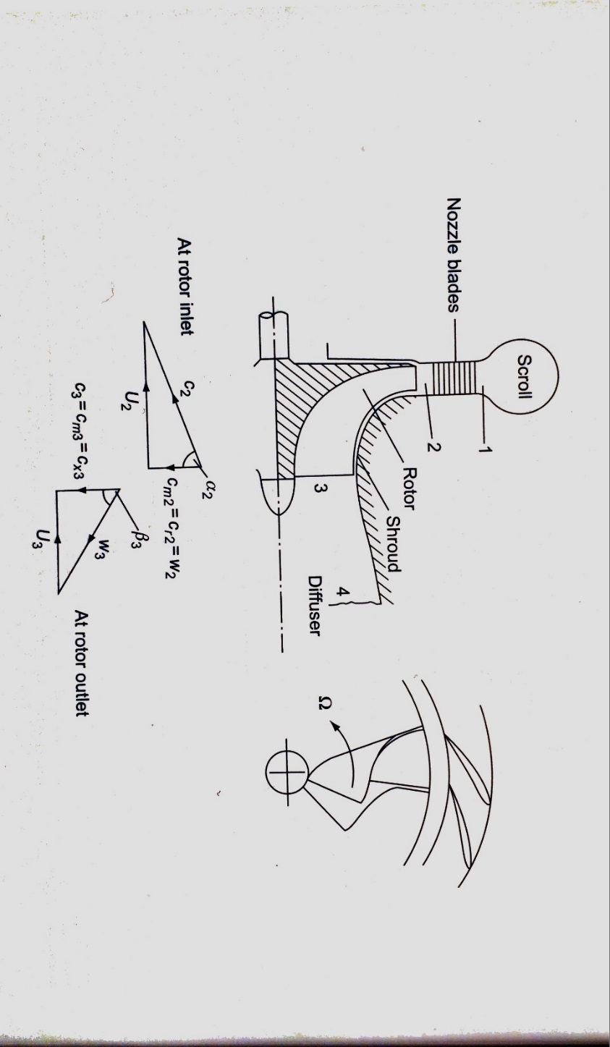
2 mark for sketch and arrow and 1 for labelling the rotor and scroll. [3]

10. Figure Q10 shows the velocity vectors concerned with an oblique shock formed by a supersonic flow approaching an inclined wall. State the effect of the shock on the entering velocity. The direction of the resultant, and the meaning of weak shock and strong shock should be addressed. Your answer must be limited to 100 words, any further words will not be assessed. [7]

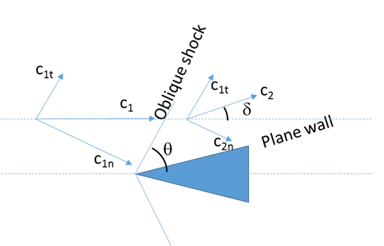
Figure Q10

The velocity tangential to the oblique shock is unaffected [1]. The velocity component normal to the shock is adjusted such that the resultant velocity vector is parallel to the wall [2]. A weak shock is where the Mach number is reduced but still supersonic [2] and a strong shock is where the Mach number is reduced to subsonic [2].

Section B
Answer ALL question in this section

11. (a) A turbine stage is to be designed with a flow coefficient of 0.6, a reaction of 50% and a stage loading of 3. Use the given formulae to derive an expression for the relative velocity angles at entry and exit. Calculate the entry and exit relative flow angles using the data given and sketch the velocity triangles of the rotor inlet and outlet stating any conditions that you use to determine the shape of the triangles [9]

(b) A flow of air at Mach 2.5 expands around a corner of angle 20°. Use the Prandtl-Meyer chart to determine the exit Mach number. Make a sketch of the chart in your answer book to indicate the angle change and Mach number change and briefly explain the principle of the chart making clear why it starts at Mach 1. Your answer must be limited to 150 words, any further words will not be assessed. [6]
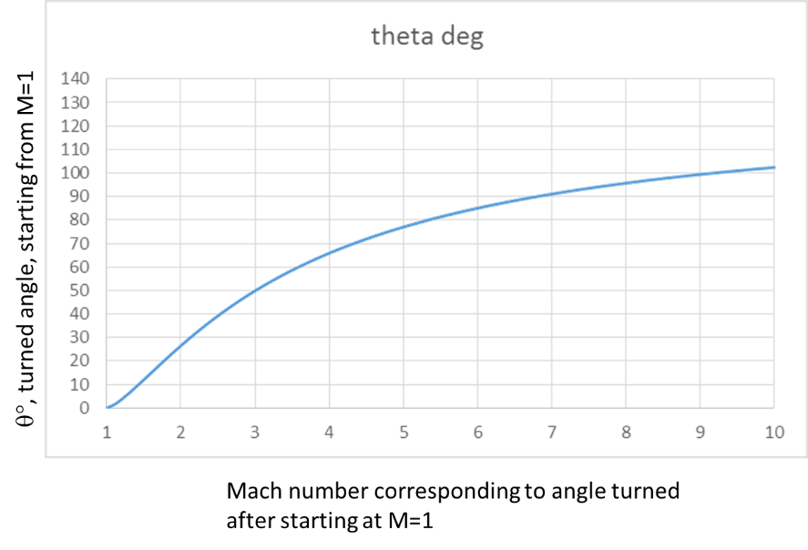
Figure Q.11a

- Stage loading is from the formula sheet:
$$ψ=\frac{h_{0}}{U^{2}}=\frac{w_{θ3}-w_{θ2}}{U}=∅\left(tanβ_{3}+tanβ_{2}\right)$$
Reaction is from the formula sheet:
$$R=ϕ{\left(tanβ_{3}-tanβ_{2}\right)}/2$$
Combining these equations yields:
$$tanβ_{3}=\frac{ψ/2+R}{ϕ}$$
and
$$tanβ_{2}=\frac{ψ/2-R}{ϕ}$$
[3]
Since the values are given, the angles are:
$$R=0.5, ψ=3, ϕ=0.6$$
So:
$$tanβ_{3}=\frac{3/2+0.5}{0.6}=3.33, β_{3}=73.3$$
$$tanβ_{2}=\frac{3/2-0.5}{0.6}=1.67, { β}_{2}=59.0$$
[3]
The sketch must be symmetrical by definition of the effect of 50%, α₂ = β₃:
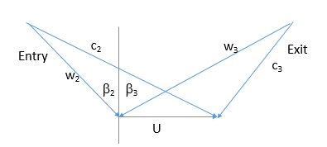
[3]
(b) Use the chart to determine the increase in Mach number as the fan expands around the bend:
From the plot, the data can be extracted from the M = 2.5 corresponding to the Mach 1 case turning 40° in the fan [2], adding the further 20° to make 60° turning [2], and read the corresponding Mach number, M = 3.6 [2]. The expansion fan is determined by considering the infinitesimal changes of angle from a Mach 1 starting point, so that when the Mach number is higher, the start point on the chart at the actual Mach number assumes that the flow has expanded to that point from M=1.

c) A hot plate at 100 °C is cooled by attaching 30 mm long and 2.5 mm diameter aluminium pin fins ($k=237 W/mK)$ to the surface to improve the cooling rate. There are 100 pins in a 10 x 10 array on the plate, and the plate is 50 mm x 50 mm in size. Assume that the surrounding medium is at 30 °C and that the heat transfer coefficient from all surfaces is $35 W/m^{2}K$. The rate of heat transfer from the flat plate without fins is 6.125 W. The interfin area between the pin fins is $A_{if}=2.01×{10}^{-3}m^{2}$. The surface area of one pin fin is $A_{fin}=2.36×{10}^{-4}m^{2}$.

i) What is the value of the shape factor $m$ for this design of pin fins? [5]
ii) What is the efficiency of the fins assuming that the adiabatic tip assumption is valid? [3]
iii) What will be the rate of heat transfer from the complete heat sink including the remaining base plate after the pin fins are attached? [5]
iv) What is the effectiveness for the entire heat sink including the base plate? [2]

Efficiency in adiabatic tip approximation is given by:
$$η=\frac{\tanh\left(m L_{c}\right)}{m\left(L_{c}\right)}$$
- Shape factor for fins is ( 2 for correct perimeter and area) 2 for putting all together and 1 marks for putting right units:
$$m=\sqrt{\frac{hP}{kA}}=\sqrt{\frac{\left(35\right)\left(π0.0025\right)}{237 \left(π{\left(\frac{0.0025}{2}\right)}^{2}\right) }}=\sqrt{236}=15.37m^{-1}$$
- They can use 0.03m for length of fin or 0.03125 m if they add the end correction, I will accept both i
Efficiency given by:
$$η=\frac{\tanh{(15.37 (0.03})) }{15.37 (0.03)}=0.935$$
- Interfin area of base plate $A_{if}=2.01E-3 m^{2}$
So heat loss from base is ( 2mark) ${\dot{q}}_{base}=A_{if}h\left(ΔT\right)=2.01E-3\left(35\right)\left(70\right)=4.925W$
Heat loss from one fin is (2 mark):
$${\dot{q}}_{fin}=hA_{f}ηΔT=35π0.0025\left(0.03\right)\left(0.935\right)\left(70\right)=0.5397 W$$
So total heat loss is (1 mark): ${\dot{q}}_{base}+100{\dot{q}}_{fin}=4.925+100\left(0.5397\right)=58.895W$
- Fin effectiveness is heat loss through heat sink/heat loss without heat sink.
$$ϵ=\frac{58.895}{6.125}=9.6$$

12 a) A furnace is shaped as a long equilateral triangular duct as shown in figure Q12a. The width of each side of the furnace is 1 m. The base surface has an emissivity of 0.7 and is maintained at a uniform temperature of 600K. The heated left side surface closely approximates a blackbody at 1000K. The right side is well insulated
i) Identify the values of each thermal resistance and both the black body emissions ($E_{b1}$ and $E_{b2}$) in figure Q12a.
[12]
ii) Determine the rate that heat must be supplied to the heated side per unit length of the duct in order to maintain these conditions. [3]
Side 1: $ϵ_{1}=0.7$
$$T_{1}=600K$$
Side 2: black
$$T_{2}=1000K$$
Side 3: insulated
$${\dot{Q}}_{1}$$
$${{\dot{Q}}_{2}=-\dot{Q}}_{1}$$
$$J_{2}=E_{b2}$$
$$E_{b1}$$
$$R_{1}$$
$$R_{2}$$
$$R_{12}$$
$$R_{23}$$
$$R_{13}$$
$J_{3}=E_{b3}$
$${\dot{Q}}_{3}=0$$
$$J_{2}$$
$$J_{1}$$
Figure Q12a
- Need view factors first:
(2 marks) Only need $F_{13}$, $F_{12}$ and $F_{23}$ and they are all equal to 0.5 from symmetry. No additional marks for solving the algebra.

( 1 mark) Areas of surfaces are all the same as 1m² .

1 mark each:1 markfor units (7 marks in total)
$$R_{1}=\frac{1-ϵ_{1}}{ϵ_{1}{ A}_{s}}=\frac{1-0.7}{0.7\left(1\right)}=0.4286 K^{4}/W$$
$$R_{2}=\frac{1-ϵ_{2}}{ϵ_{2}A_{s}}=0 K^{4}/W$$
$$R_{12}=\frac{1}{F_{12}A_{s}}=\frac{1}{0.5\left(1\right)}=2 K^{4}/W$$
$$R_{13}=\frac{1}{F_{13}A_{s}}=2 K^{4}/W$$
$$R_{23}=2 K^{4}/W$$
$$E_{b1}=σT_{1}^{4}=5.67E-8\left({600}^{4}\right)=7348.3 W/m^{2}$$
$$E_{b2}=σT_{2}^{4}=5.67E-8 \left({1000}^{4}\right)=56700 W/m^{2}$$

- The resistance of the centre section can be determined from:
$$\frac{1}{R_{Δ}}=\frac{1}{R_{12}}+\frac{1}{R_{13}+R_{23}}=0.5+\frac{1}{4}=0.75. So R_{Δ}=1.33K^{4}/W$$
Total resistance is (1 mark):
$$R_{all}=R_{1}+R_{Δ}+R_{2}=0.4286+1.33+0=1.762 K^{4}/W$$
Heat flow is then (1 mark):
$$\dot{Q}=\frac{E_{b1}-E_{b2}}{R_{all}}=\frac{56700-7348.3}{1.762}=28000 W$$

12 b

A heat pump as shown in Figure Q12b is used to provide heating for a building. The outside environment air temperature is 5°C and the temperature inside the building is 21°C. The heat pump operates with working fluid R134a. The saturation temperature in the evaporator is 0°C and the saturation temperature in the condenser is 40°C. The electric motor has an efficiency of 90%.
2
3
4
1
Compressor
Evaporator
Condenser
Throttle
Valve
Electric
Motor
Heat input from environment
Heat output to building

Figure Q12b

If the rate of heat input to the building is 25 kW, calculate:

- the mass flow rate of the working fluid (R-134a); [2]

ii) the rate of exergy input to the building needed to maintain the internal temperature of 21°C; [3]

iii) the Coefficient of Performance of the heat pump and the overall Rational Efficiency of the heat pump in providing heat for the building; [3]

iv) the rate of irreversibility in the compressor, motor, evaporator, condenser and throttle. [4]

v) Discuss the reasons for the irreversibilities in the evaporator and condenser and how these may be reduced. (Write no more than about 100 words) [3]

The specific enthalpy and specific exergy at each point around the cycle is as shown below:

 |  |  |  | Specific | Specific
 | Pressure | State | Temperature | Enthalpy | Exergy
 | [bar] |  | [°C] | [kJ/kg] | [kJ/kg]
1. | 2.928 | Dry Sat vapour | 0.0 | 398.43 | 20.09
2. | 10.163 | S/H vapour | 60.0 | 441.32 | 48.41
3. | 10.163 | Sat liquid | 40.0 | 256.38 | 27.07
4. | 2.928 | Wet vapour | 0.0 | 256.38 | 22.62

Environment temperature is the outside temperature of 5°C.

- The mass flow rate of the refrigerant is found from an enthalpy balance on the condenser. Heat output to building = change in enthalpy of refrigerant in condenser. $\dot{Q}$ = $\dot{m}\left(h_{2}-h_{3}\right)$
$\dot{m}$ = 25/(441.32 – 256.38) = 0.135 kg/s [2 marks]

- Exergy input to the building is exergy of heat transfer into building which is determined from where T₁ is building temperature (21°C, 294K), T₀ = environment temperature (5°C, 278K) and Q₁ is the rate of heat input to the building.
Exergy input = 25 ((294 – 278)/294) = 1.36 kW. [3 marks]

- Work input needed to compressor = mass flow (h₂ – h₁)
= 0.135×(441.32 – 398.43) = 5.80 kW.
Electric motor efficiency is 90%, so electrical input power = 5.80/0.90 = 6.44 kW [1 mark]
So COP is = Useful Heat Output/ Electricity input = 25/6.44 = 3.88. [1 marks]
Rational efficiency = Exergy output/exergy input = 1.36/6.44 = 21.1 % [1 marks]

- Evaluate flow exergy at each point in cycle from:
Flow exergy = specific exergy × mass flow of working fluid
Specific Exergy Flow Exergy
kJ/kg kW
1. 20.09 2.72
2. 48.41 6.54
3. 27.07 3.66
4. 22.62 3.06

Undertake exergy balance on evaporator and condenser:
Irreversibility = exergy in - exergy out
Irreversibility in motor is 6.44 – 5.80 = 0.64 kW
Irreversibility in compressor is 5.80 – (6.54 – 2.72) = 1.98 kW
Irreversibility in evaporator is: 3.06 – 2.72 = 0.34 kW
Irreversibility in condenser is: (6.54 – 3.66) – 1.36 = 1.52 kW
Irreversibility in throttle is 3.66 – 3.06 = 0.6 kW
[4 marks]

- The irreversibility in the evaporator and condenser may be reduced as follows:
The condenser has a large irreversibility and this is due to the temperature difference between the working fluid and the room. Operating at a lower outlet pressure from the compressor help, but this would require a larger heat exchanger as the temperature difference would be lower.
Similarly a smaller temperature difference in the evaporator would reduce the irreversibility and improve the performance of the system. This would mean that the temperature and pressure of the refrigerant in the evaporator would increase. [3 marks]

END

